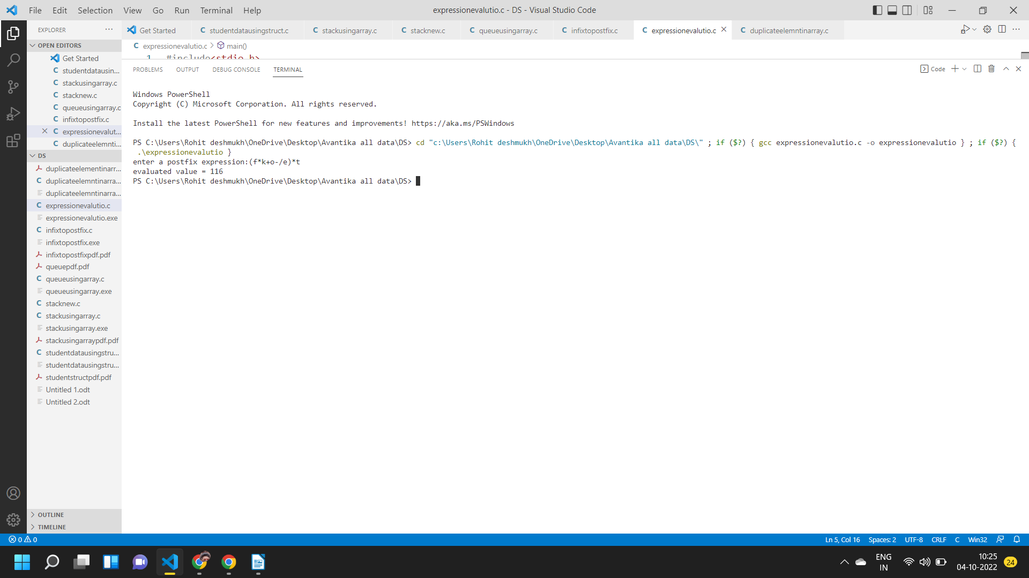
#include<stdio.h>
#include<conio.h>

int top = -1, stack [100];
void main ( ){
char a[50], ch;
int i,op1,op2,res,x;
void push (int);
int pop( );
int eval (char, int, int);
printf("enter a postfix expression:");
gets (a);
for(i=0; a[i]!='\0'; i++){
ch = a[i];
if (ch>='0' && ch<='9')
push('0');
else{
op2 = pop ( );
op1 = pop ( );
res = eval (ch, op1, op2);
push (res);
}
}
x = pop ( );
printf("evaluated value = %d", x);
getch ( );
}
void push (int n){
top++;
stack [top] = n;
}
int pop ( ){
int res ;
res = stack [top];
top--;
return res;
}
int eval (char ch, int op1, int op2){
switch (ch){
case '+' : return (op1+op2);
case '-' : return (op1-op2);
case '*' : return (op1*op2);
case '/' : return (op1/op2);
}
}

